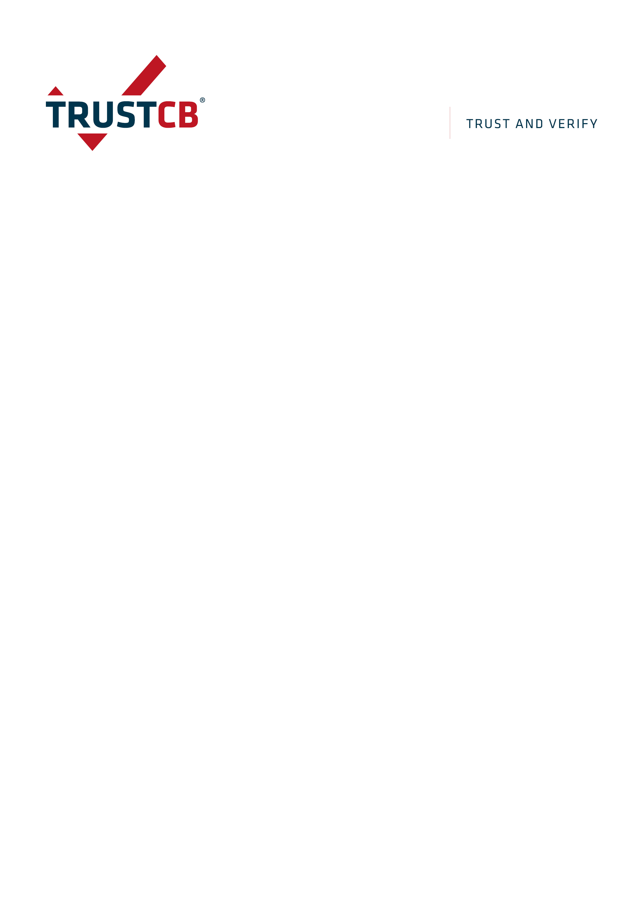
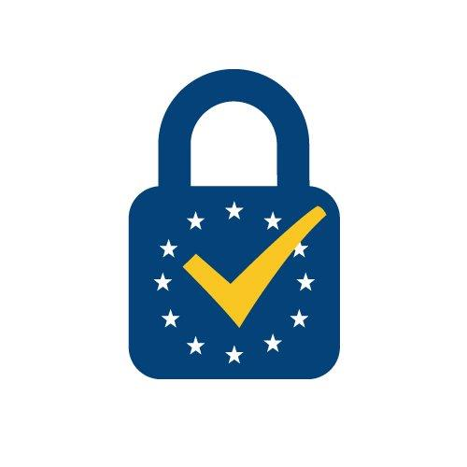

Application Form for eIDAS notification

This application form is intended to register a QSCD (qualified electronic signature and/or qualified electronic seal creation devices) in order to be submitted for publishing by TrustCB B.V. as being eIDAS designated body acting under the Ministry of Economic Affairs.

This application form shall be signed and emailed in PDF format to nscib_application@trustcb.com.

Form version: | 1.2
Form version date: | 2024-09-23

Application Form

General introduction and eIDAS
TrustCB B.V. is designated by the Dutch Ministry of Economic Affairs as certifying body of qualified means for creating electronic signatures and seals, as referred to in Article 30 of REGULATION (EU) No 910/2014 OF THE EUROPEAN PARLIAMENT AND OF THE COUNCIL of 23 July 2014 on electronic identification and trust services for electronic transactions in the internal market and repealing Directive 1999/93/EC [eIDAS Regulation].
The EU Digital Identity Framework Regulation (EU) 2024/1183 of the European Parliament and of the Council of 11 April 2024 amends Regulation (EU) No 910/2014 as regards establishing the European Digital Identity Framework. The amending provisions of this regulation entered into force on 20th May 2024.

Terms and disclaimers
Evaluation results only apply to the specific version or identification of the object as defined in the Security Target.
After agreement TrustCB B.V. will request the necessary documents in order to assess the conformity of the IT-product with relevant EU-legislation under the 910/2014. The results laid down in the ‘request for notification’ will be reviewed by the Dutch Ministry of Economic Affairs and with positive results notified by this Ministry to the European Commission.
Issuance of a certificate and notification of a product is not a guarantee that the product is free from security vulnerabilities. It does not absolve the Vendor of any liability for damages resulting from the use of the product.
A certificate is also not an endorsement or recommendation for use of the object by TrustCB B.V. or by other organisations that recognises or gives effect to the certificate, and no warranty of the object by TrustCB B.V. or by any other organisation that recognises or gives effect to the certificate, is either expressed or implied.

Rights and obligations
The sponsor must comply with the provisions of the NSCIB scheme with the exclusion of the Purchase Conditions of sponsor and shall make all necessary arrangements for the conduct of the evaluation for NSCIB being preconditional for eIDAS-certification. The provisions of the NSCIB scheme are published on the NSCIB website.
The sponsor must comply with the provisions of the eIDAS REGULATION (EU) No 910/2014 and of the EU Digital Identity Framework Regulation (EU) 2024/1183.
eIDAS certificates are issued with a validity period of a maximum of 5 years with a condition that vulnerabilities assessments are carried out every two years. Where vulnerabilities are identified and not remedied, the certification shall be cancelled. (reference: (EU) 2024/1183 article 1 (29) amending Article 30 of 910/2014, entered into force 20th May 2024.
The issuance of a certificate may be used by the sponsor for advertising the object as long as it is understandable for the consumers and not misleading. The sponsor will:
- not claim the certificate has been issued while the object is still under evaluation;
- ensure that all objects referencing the certificate and/or the international Recognition Marks are manufactured or produced by the companies listed in the certificate and conform to the evaluated security characteristics;
- ensure that every alteration to the object results in a new version of the object not concerned by the certificate;
- advertise the listing of the object only for those security characteristics that were in scope of the evaluation;
- immediately discontinue to advertise the object as being certified when the object is no longer listed by TrustCB B.V. (i.e. certificate is expired or withdrawn).
TrustCB B.V. reserves the right to take all necessary steps against any misuse of the TrustCB Certification Mark and international Recognition Marks.

Confidentiality of the assessment
All parties involved are committed to keep the existence of this assessment confidential between all parties involved as long as it is in progress.
Should the object fail the certification, all parties are committed to ensure the confidentiality of this assessment, including the associated (intermediate) results and verdicts.
TrustCB holds an ISO17065 accreditation issued by the RvA, Dutch Accreditation council. As part of their accreditation activities, RvA may audit or witness any accredited certification activity performed by TrustCB.

Costs related to certification/publication
TrustCB B.V. charges the costs for the certification and notification process in accordance with the price list as published on the NSCIB website. These costs will basically consist of a certification fee under the condition that QSCD-specific documentation meet the requirements under 2.x of this application form. If this will not be the case, it can be that additional costs are made and invoiced after mutual coordination and agreement. There are no periodical costs involved.

Scope of examination

Object description
QSCD name:
Reference ID:
(If applicable unique identifier other than QSCD-name)
Version:
Short description:
Type QSCD: | Type 1: Type 2:
Note:
- a Type 1 QSCD is either a smartcard or HSM-based device where the electronic signature/seal creation data is held in an entirely but not necessarily exclusively user-managed environment;
- a Type 2 QSCD is an HSM-based device where a Qualified Trust Service Provider manages the electronic signature/seal creation data on behalf of a signatory/creator of a seal.
QSigCD/QSealCD | QSigCD: QSealCD:
Protection profiles: | EN 419 211-2: Protection profiles for secure signature creation device — Part 2: Device with key  generation
Protection profiles: | EN 419 211-3: Protection profiles for secure signature creation device — Part 3: Device with key import
EN 419 211-4: — Protection profiles for secure signature creation device — Part 4: Extension for device
with key generation and trusted channel to certificate generation application
EN 419 211-5: Protection profiles for secure signature creation device — Part 5: Extension for device
with key generation and trusted channel to signature creation application
EN 419 211-6: Protection profiles for secure signature creation device — Part 6: Extension for device
with key import and trusted channel to signature creation application
 | EN 419 221-5: Protection Profiles for TSP Cryptographic Modules - Part 5 – Cryptographic Module for Trust Services
 | EN 419 241-2: Trustworthy Systems Supporting Server Signing Part 2: Protection Profile for QSCD for Server Signing
Other Protection Profiles (specify)

.................................................................................
.................................................................................
.................................................................................

Note: When claiming another Protection Profile, the security objectives for the TOE and for the operational environment must ensure that the security claim is in line with the requirements from Annex II of the eIDAS regulation and that the statement of security problem definition is equivalent or more restrictive than the statement of security problem definition in the PP(s) of the EN 419 211 series referenced in Article 30(3)(a).

None

Note: When claiming no Protection Profile, the security objectives for the TOE and for the operational environment in the ST must ensure that the security claim is in line with the requirements from Annex II of the eIDAS regulation and that the statement of security problem definition is equivalent or more restrictive than the statement of security problem definition in the PP(s) of the EN 419 211 series referenced in Article 30(3)(a).

REGULATION (EU) No 910/2014 OF THE EUROPEAN PARLIAMENT AND OF THE COUNCIL of 23 July 2014 on electronic identification and trust services for electronic transactions in the internal market and repealing Directive 1999/93/EC | Article 30(3)(a)
 | Article 30(3)(b) with alternative process DCAP version 6.0

Which ‘case’ in DCAP is applicable 5? | Case A
Which ‘case’ in DCAP is applicable 5? | Case B
Which ‘case’ in DCAP is applicable 5? | Case C
The Sponsor requests and allows the existence of the ongoing assessment be made public.
This would result in an entry of the object under “ongoing certifications” on the TrustCB website (https://trustcb.com/common-criteria/nscib/nscib-certificates/) by listing of the name of the developer, name of the object, product category, assurance level and certification identification related to eIDAS:

Required documents for eIDAS application
This completed and signed application form (template can be downloaded from https://trustcb.com/common-criteria/nscib/
- Security Target (ST) as detailed in section ‘Scope of Assessment’ of this document, to align with the ST provided for the associated NSCIB-evaluation.
In addition, a Compliance Mapping Matrix indicating coverage by the TOE in its operational environment (device with guidance) of the requirements laid down in Annex II of [1] shall be provided directly to the ITSEF performing the eIDAS evaluation.

Publication of the certificate
A positive result of the eIDAS assessment is the issuing of an eIDAS-certificate.
TrustCB B.V. will list the QSCD as being eIDAS-certified on the TrustCB website for NSCIB certificates (https://trustcb.com/common-criteria/nscib/nscib-certificates/). The Certification Report with certificate and Security Target will also be published on this website. After this publication TrustCB B.V. will submit a request for eIDAS-notification on the EU eIDAS Dashboard.

Signatures

Sponsor
I hereby declare that I've read the terms in section 1 above and that all relevant contractual agreements with the ITSEF (and, where relevant, the developer) have been arranged and hereby request to start the process for the eIDAS certification and notification of the object identified above.

Name, title and organisation name:
Location:
Date:
[Signature of the person that legally represents the sponsor]

ITSEF
I hereby declare that I've read the terms in section 1 above and commit to the responsibilities of the ITSEF. The object to be evaluated falls in a category for which my ITSEF is licensed. I also declare that all relevant contractual agreements with the sponsor (and, where relevant, the developer) have been arranged.

Name, title and organisation name:
Location:
Date:
[Signature of the person that legally represents the ITSEF]

Annex A: Certification Agreement eIDAS
The sections below will be filled in by TrustCB and returned after the application has been accepted. The sponsor is then to sign for agreement of the certification costs.

Conformity Certification Agreement
Following receipt of the eIDAS Application Form, signed by the sponsor on <date>, it is understood the Sponsor wishes to have the object certified by TrustCB according to the REGULATION (EU) No 910/2014 OF THE EUROPEAN PARLIAMENT AND OF THE COUNCIL of 23 July 2014 on electronic identification and trust services for electronic transactions in the internal market and repealing Directive 1999/93/EC and agrees with the terms in section 1 of this Application Form.
TrustCB B.V.
TrustCB B.V. agrees to supervise the evaluation of the sponsor’s object as performed by the listed ITSEF to ascertain that the provisions of the eIDAS-regulation are met. TrustCB will then issue sponsor with a Certificate.
For the eIDAS assessment , eIDAS-certificate-issue under RvA-accreditation and request-to-notify at the EU eIDAS Dashboard, the cost is: €2,500 per product.
Unless agreed otherwise, all prices mentioned in this Agreement are net prices; banking charges are for the account of sponsor.
An invoice of 100% of the costs is payable before the start of the certification.
The mentioned costs are based on the tariffs of 202x excluding VAT and subject to changes.
Termination of the certificate by Sponsor has to be done in writing, at least 1 month before the desired end date.
This agreement is drawn up under Netherlands Law and any disputes arising hereunder shall be resolved in accordance with the laws of the Netherlands.
Name, title and organisation name: | Wouter Slegers, CEO  Van den Berghlaan 48, 2132 AT Hoofddorp, The Netherlands
Date:
 | [Signature of the person that legally represents TrustCB B.V.]
Sponsor
I hereby agree with the conditions and certification costs as specified above and understand the certification commences after payment of the invoice.
Name, title and organisation name:
Date:
[Signature of the person that legally represents the sponsor]

See https://nscib.nl
See https://nscib.nl
The name of the product will be listed on the certificate precisely as indicated here.
A further description of a type 1 and 2 QSCD can be found in the eIDAS Dutch Conformity Assessment Process (DCAP) located at https://trustcb.com/common-criteria/nscib/nscib-scheme-procedures/

